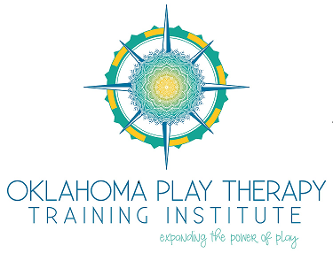

COMPLAINT PROCEDURES

Oklahoma Play Therapy Training Institute is committed to provide quality instruction to professionals wanting to learn more about the field of play therapy. If for any reason an attendee is not completely satisfied with the services offered, we ask that the follow procedures be followed to ensure proper handling of any complaints.

1. An attendee should first voice their concern in writing on the provided evaluation sheet at the end of a training. If as an attendee you would like to discuss how this issue is going to be resolved, please leave your name and contact number on the evaluation. OKPTTI will do everything in its power to resolve the issue.
2. If the concern is not due to a specific workshop attended, a written complaint can also be mailed or emailed to OKPTTI. You should include contact information so that the owners can speak with you directly to help resolve the issue.
3. If after writing a concern AND speaking directly with the owners of OKPTTI you feel as your complaint is not being handled properly, you make take your complaint to the credentialing bodies of the workshop.

**Contact Information**

Oklahoma Play Therapy Training Institute, LLC

3700 N. Classen, Ste. 185

Oklahoma City, OK 73118

[oklahomaplaytherapy@gmail.com](mailto:oklahomaplaytherapy@gmail.com)

(405) 413-4768

The Association for Play Therapy

401 Clovis Avenue, Suite 107   
Clovis, CA 93612

(559) 298-3400

Oklahoma State Board of Licensed Social Workers

3700 N Classen Blvd #162

Oklahoma City, OK 73118

(405) 521-3712

Oklahoma State Board of Behavioral Health

3815 N. Santa Fe, Suite 110  
Oklahoma City, OK 73118  
(405) 522-3696